**EXCELL ASSIGNMENT – 16**

**QUESTION 1. What is a Macro? How is it useful in excel or in your daily work?**

**ANSWER-**

A macro in the context of Microsoft Excel refers to a sequence of instructions that can be triggered to automate repetitive tasks. These instructions are written in VBA (Visual Basic for Applications), a programming language developed by Microsoft. Here's a breakdown of the concept:

**What is a Macro?**

1. **Sequence of Commands:**
   * A macro is essentially a recorded set of instructions that can be executed to perform a specific task or a series of tasks.
2. **Automation:**
   * Macros are used to automate repetitive actions in Excel. Instead of manually performing the same steps over and over again, you can record those steps as a macro and then execute it with a single command**.**
3. **VBA Code:**
   * Behind the scenes, a macro is represented by VBA code. When you record a macro, Excel translates your actions into VBA code. You can also write or edit this code directly to customize or extend the functionality.

**How is it Useful in Excel or Daily Work?**

1. **Time Efficiency:**
   * Macros help save time by automating repetitive tasks. This is particularly useful when dealing with large datasets, complex calculations, or formatting tasks that need to be applied consistently.
2. **Accuracy:**
   * Automation reduces the chance of errors that can occur during manual data entry or repetitive tasks. Macros perform tasks consistently based on the recorded or written instructions.
3. **Consistency:**
   * Macros ensure that specific processes are executed uniformly across different datasets or sheets. This consistency is crucial for maintaining data integrity.
4. **Complex Calculations:**
   * For complex calculations or data manipulations, macros can be programmed to handle the intricacies efficiently. This is especially beneficial for tasks that involve multiple steps or complex logic.
5. **Task Repetition:**
   * Daily work often involves repetitive tasks, such as data cleaning, formatting reports, or updating charts. Macros allow you to perform these tasks quickly, freeing up time for more strategic or creative work.
6. **Customization:**
   * With VBA, you can customize macros to fit your specific needs. This level of flexibility allows you to create tailored solutions for your unique requirements.

QUESTION-2 . What is VBA? Write its full form and briefly explain why VBA is used in

excel?

ANSWER-

**VBA** stands for **Visual Basic for Applications**. It is a programming language developed by Microsoft that is embedded in most Microsoft Office applications, including Excel. VBA allows users to create macros and automate tasks within the Microsoft Office suite.

**Why VBA is Used in Excel:**

1. **Automation:**
   * VBA is used in Excel primarily for automation. It allows users to record, write, and execute macros, which are sequences of instructions that automate repetitive tasks. This can include tasks such as formatting data, generating reports, or performing complex calculations.
2. **Customization:**
   * With VBA, users can customize and extend Excel's functionality. You can create custom forms, add new features, or modify existing ones to suit specific needs. This level of customization is particularly useful for professionals with specialized requirements.
3. **Data Manipulation:**
   * VBA provides powerful tools for manipulating data in Excel. Users can write scripts to perform complex calculations, filter and sort data, and transform datasets. This is valuable for tasks that go beyond the capabilities of standard Excel functions.
4. **Task Integration:**
   * VBA enables the integration of Excel with other Office applications and external data sources. Users can automate data imports, exports, and interactions with other software, streamlining workflows.
5. **Efficiency:**
   * By automating repetitive tasks, VBA enhances efficiency. It reduces the time and effort required to perform routine operations, allowing users to focus on more complex and value-added activities.
6. **Complex Modeling:**
   * For users dealing with advanced financial modeling, simulations, or statistical analysis, VBA offers the ability to create sophisticated models and algorithms that might be challenging or impossible with Excel formulas alone.
7. **User Forms:**
   * VBA allows the creation of custom user forms. This is useful for building interactive interfaces that guide users through processes, collect input, or display information in a structured way.
8. **Event Handling:**
   * VBA enables the handling of events in Excel, such as button clicks, worksheet changes, or workbook openings. This allows for dynamic responses to user actions or changes in the spreadsheet.

**QUESTION -3. How do you record a macro? Write detailed steps to create a macro to**

**automatically make the following table in bold and to create borders for**

**it in excel.**

**Hi 78**

**hello 69**

**ineuron 45**

**ANSWER-**

1. **Open Excel:**
   * Open Microsoft Excel and the workbook where you want to create the macro.
2. **Enable Developer Tab:**
   * If the Developer tab is not visible, you need to enable it. Go to "File" -> "Options" -> "Customize Ribbon." Check the "Developer" option and click "OK."
3. **Navigate to Developer Tab:**
   * Click on the "Developer" tab in the Excel ribbon. If you don't see the Developer tab, you need to enable it using the step above.
4. **Record Macro:**
   * In the "Developer" tab, click on "Record Macro." This will open the "Record Macro" dialog box.
5. **Fill in Macro Details:**
   * In the "Record Macro" dialog box, you need to provide some details:
     + **Macro Name:** Enter a name for your macro. Avoid spaces and special characters.
     + **Shortcut Key (Optional):** If you want to assign a shortcut key, type a letter (Excel will use Ctrl + [your letter]).
     + **Store Macro In:** Choose where you want to store the macro (in the current workbook or a new one).
     + **Description (Optional):** You can add a description if needed.
6. **Choose a Location:**
   * Select a location for your macro:
     + **New Workbook:** If you want the macro to be available whenever you open Excel.
     + **This Workbook:** If you want the macro to be available only in the current workbook.
7. **Click "OK" to Start Recording:**
   * Once you've filled in the details, click "OK" to start recording.
8. **Perform Actions:**
   * Excel is now recording your actions. Perform the steps you want to include in your macro (e.g., formatting cells, entering data, etc.).
9. **Stop Recording:**
   * After you have completed the actions you want to include in your macro, go back to the "Developer" tab and click on "Stop Recording" in the "Code" group.

Your macro is now recorded and can be run at any time to repeat the recorded actions. If you assigned a shortcut key, you can use that to execute the macro. Macros are a great way to automate repetitive tasks in Excel.

STEP-1.

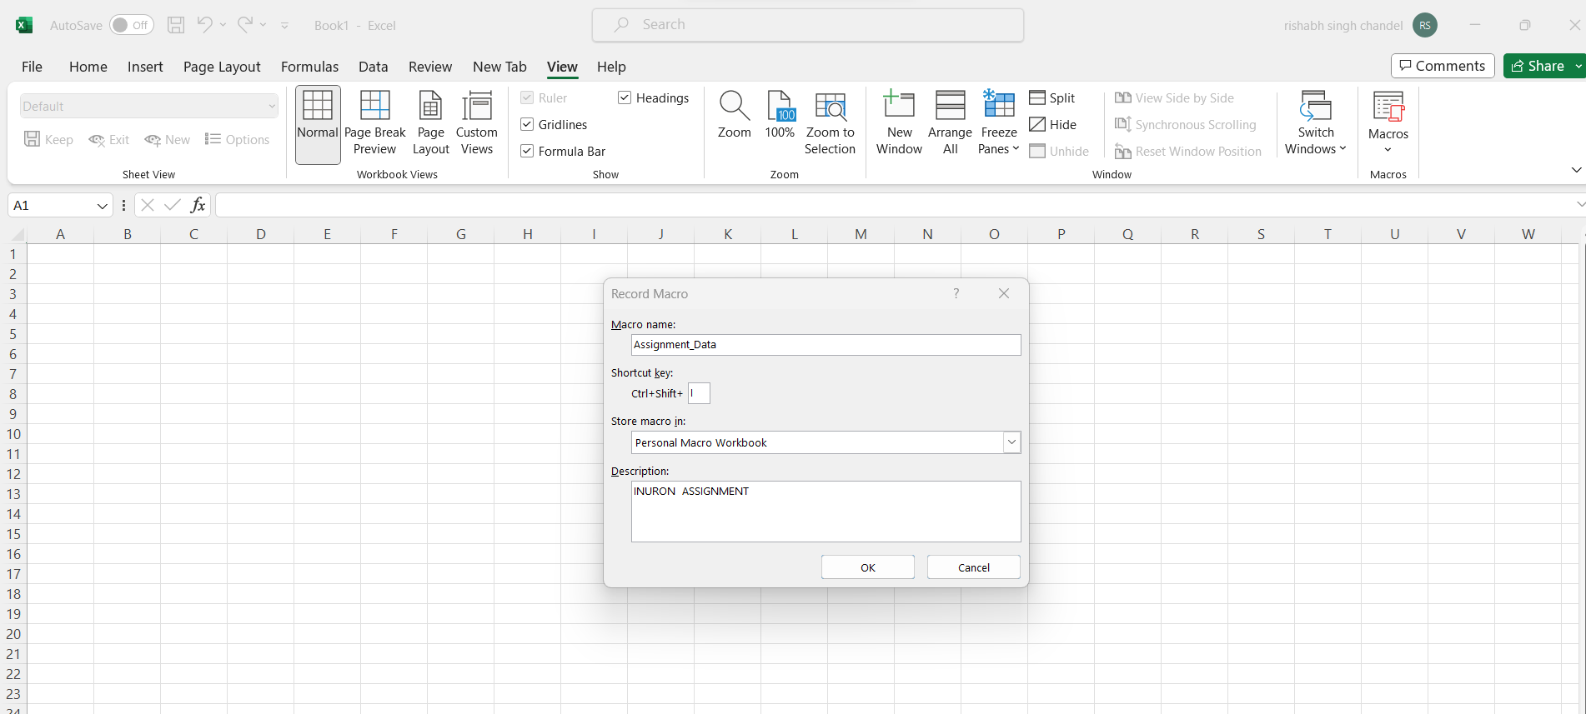

STEP -2.

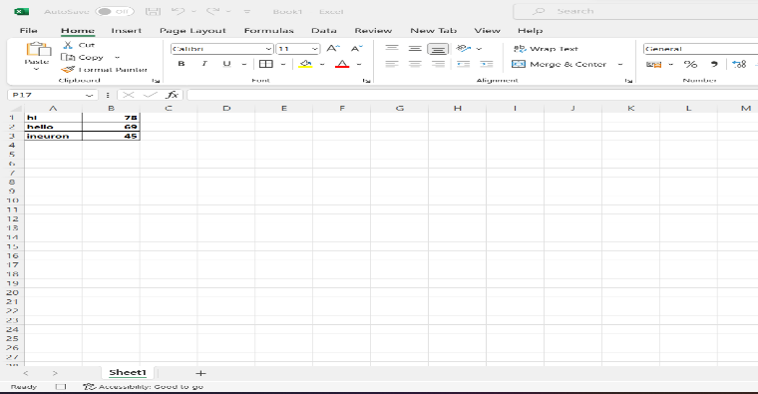

STEP-3. After recording Macros in Sheet 2 , I will do same activity in Sheet 2 using CTRL+I that I have already created before recording

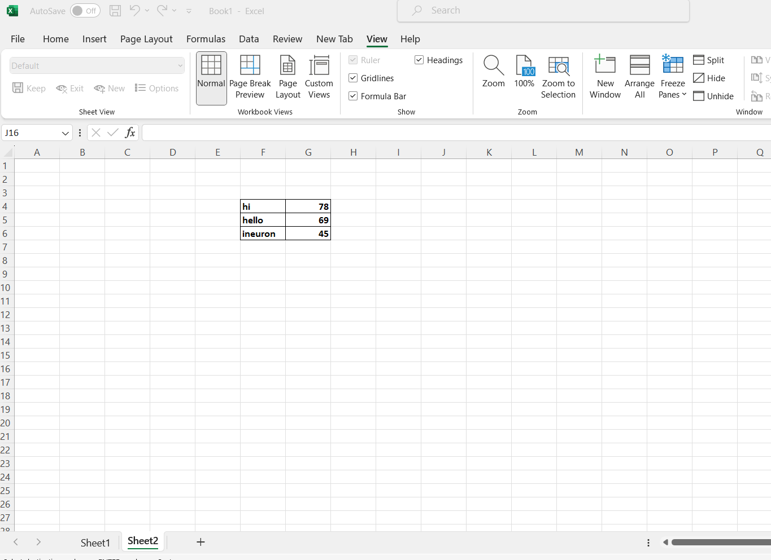

**QUESTION 4. What do you mean when we say VBA Editor?**

**ANSWER-**

**The VBA Editor, also known as the Visual Basic for Applications Editor, is an integrated development environment (IDE) provided by Microsoft for writing, editing, and managing VBA code. It is a tool that allows you to work with the Visual Basic for Applications programming language within Microsoft Office applications, including Excel.**

**When we refer to the VBA Editor, we are talking about the environment where you can:**

**QUESTION 5.** **Briefly describe the interface of a VBA editor? What is properties**

**window? And what is watch window? How do you display these**

**windows?**

**Answer-**

The VBA Editor interface is a comprehensive environment for writing, editing, and managing Visual Basic for Applications (VBA) code. Here's a brief overview of the main components of the VBA Editor interface:

**VBA Editor Interface:**

1. **Project Explorer:**
   * The Project Explorer is on the left side of the VBA Editor. It displays a hierarchical view of all the objects in your VBA project, including workbooks, modules, forms, and class modules.
2. **Code Window:**
   * The central area is the Code Window. This is where you write, edit, and view your VBA code. It displays the code associated with the selected object in the Project Explorer.
3. **Immediate Window:**
   * The Immediate Window is usually at the bottom of the VBA Editor. It allows you to execute immediate commands or test code snippets interactively.
4. **Properties Window:**
   * The Properties Window displays the properties of the selected object, such as forms, controls, or variables. It provides a way to view and modify the characteristics of the selected object.
5. **Watch Window:**
   * The Watch Window allows you to monitor the values of specific variables during the execution of your code. This is useful for debugging and understanding how values change as your code runs.

**Properties Window:**

* **Purpose:**
  + The Properties Window is used to view and modify the properties of the currently selected object in the VBA Editor.
* **Display:**
  + It typically appears as a separate window below the Code Window when you are working with forms, controls, or other objects.
* **How to Display:**
  + If the Properties Window is not visible, you can show it by pressing **F4** or by selecting "Properties Window" from the "View" menu.

**Watch Window:**

* **Purpose:**
  + The Watch Window is used to monitor the values of variables or expressions during the execution of your code. This helps in debugging and understanding how the data changes.
* **Display:**
  + It is a separate window that you can open and dock within the VBA Editor.
* **How to Display:**
  + If the Watch Window is not visible, you can show it by pressing **Ctrl + Alt + W** or by selecting "Watch Window" from the "View" menu.

**QUESTION 6. What is an immediate Window and what is it used for?**

**Answer-**

The Immediate Window is a tool within the VBA (Visual Basic for Applications) Editor that allows you to interactively execute statements and test code snippets during the development and debugging process. It serves several purposes and is particularly useful for the following:

1. **Immediate Execution:**
   * You can type and execute VBA statements directly in the Immediate Window. This is handy for testing a single line of code without having to run the entire macro or procedure.
2. **Debugging:**
   * During the debugging process, you can use the Immediate Window to check the current values of variables, evaluate expressions, or even modify variables on the fly. This helps in understanding how the code is behaving at different points in its execution.
3. **Variable Inspection:**
   * You can inspect the values of variables by typing their names in the Immediate Window and pressing Enter. This is beneficial for identifying issues and ensuring that variables contain the expected data.
4. **Print Statements:**
   * Instead of adding debug print statements in your code, you can use the Immediate Window to print values or messages directly. For example, you can type ? variableName to print the value of a variable.
5. **Immediate Commands:**
   * You can use immediate commands such as Debug.Print, Debug.Assert, or Stop to output information to the Immediate Window or pause code execution at a specific line for further inspection.

**How to Access the Immediate Window:**

* Press Ctrl + G while in the VBA Editor.
* Alternatively, you can select "Immediate Window" from the "View" menu.

**Example Usage:**

Sub ExampleMacro()

Dim x As Integer

X = 10

Debug.Print “The value of x is “ & x

End Sub

If you run the macro, it will print a message to the Immediate Window, helping you verify the value of variable x during execution.

The Immediate Window is a powerful tool for developers working with VBA, providing a quick and interactive way to analyze and troubleshoot code. It enhances the debugging process and allows for on-the-fly exploration of variables and expressions.